*
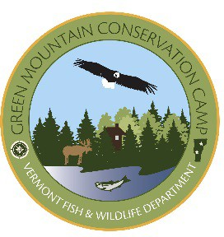
Green Mountain Conservation Camp 2018 Schedule
Supported in part with the Wallop-Breaux Amendment of the Sport Fish Restoration Act and the Wildlife Restoration Act.

“Teaching Youth about Vermont’s Natural Resources”

Buck Lake, Woodbury, Vermont

Session Dates | Boys/Girls | Type of Session
June 17 – June 22 | Boys | Basic
June 24 – June 29 | Boys | Basic
July 1 - July 6 | Girls | Basic
July 8 – July 13 | Boys | Basic
July 15 – July 20 | Teacher’s Course | No Campers
July 22 – July 27 | Boys | Basic
July 29 – August 3 | Boys | Basic
August 5– August 10 | Girls | Advanced
August 12– August 17 | Boys | Advanced

Kehoe / Lake Bomoseen, Castleton, Vermont

Session Dates | Boys/Girls | Type of Session
June 17 – June 22 | Boys | Basic
June 24 – June 29 | Girls | Basic
July 1 - July 6 | Co-Ed | Proposed Military Week  (open to military families only)
July 8 – July 13 | Boys | Basic
July 15 – July 20 | Boys | Advanced
July 22 – July 27 | Girls | Advanced
July 29 – August 3 | Boys | Advanced
August 5 – August 10 | Boys | Basic
August 12– August 17 | Girls | Basic

**July 13 – 15 The Natural Resources Management Academy is a special weekend set aside at the Buck Lake Conservation Camp for high-school students (Grades 9-12) ready to explore, in-depth, Vermont’s natural resources.
At the Academy, you’ll learn more about Vermont’s forests, wildlife, soils and
water ecology. For more information contact Lauren Traister, 4-H Teen & Leadership Specialist, at 866-260-5603 x402 or lauren.traister@uvm.edu.

For questions about Green Mountain Conservation Camp registration, call: 802-828-1460.

